**ASSIGNMENT 2 FRONT SHEET**

|  |  |  |  |
| --- | --- | --- | --- |
| **Qualification** | **BTEC Level 5 HND Diploma in Computing** | | |
| **Unit number and title** | Unit 14: Business Intelligence | | |
| **Submission date** |  | **Date Received 1st submission** |  |
| **Re-submission Date** |  | **Date Received 2nd submission** |  |
| **Student Name** | Le Thi Thanh Huyen | **Student ID** | GCD210257 |
| **Class** | GCD1102 | **Assessor name** | Nguyen Si Thin |
| **Student declaration**  I certify that the assignment submission is entirely my own work and I fully understand the consequences of plagiarism. I understand that making a false declaration is a form of malpractice. | | | |
|  |  | **Student’s signature** | Huyen |

**Grading grid**

|  |  |  |  |  |  |  |  |
| --- | --- | --- | --- | --- | --- | --- | --- |
| P3 | P4 | P5 | P6 | M3 | M4 | D3 | D4 |
|  |  |  |  |  |  |  |  |

|  |  |  |
| --- | --- | --- |
| **❒ Summative Feedback: ❒ Resubmission Feedback:** | | |
| **Grade:** | **Assessor Signature:** | **Date:** |
| **IV Signature:** | | |

ABOUT US 8

DETERMINE, WITH EXAMPLES, WHAT BUSINESS INTELLIGENCE IS AND THE TOOLS AND TECHNIQUES ASSOCIATED WITH IT (P3) 9

I. Business intelligence 9

II. Example of Business intelligence 10

1. Decentralization 10

2. KPI creation 10

3. Internal reporting for Teams 10

4. Automated Internal Structure 11

5. Inventory Control 11

6. Better Market Analysis 11

III. Tools for bi 12

1. Microsoft Power BI 12

2. Tableau 13

3. Python 15

4. Compare Power BI, Tableau and Python 15

IV. BI Techniques 16

1. Predictive Modeling 16

2. Analytics 17

3. OLAP 17

4. Data Mining 17

5. Model Visualization 17

DESIGN A BUSINESS INTELLIGENCE TOOL, APPLICATION OR INTERFACE THAT CAN PERFORM A SPECIFIC TASK TO SUPPORT PROBLEM-SOLVING OR DECISION-MAKING AT AN ADVANCED LEVEL (P4) 18

I. Python analysis 18

1. Import libraries 18

2. Import Dataset 19

3. Explain attribute information 19

4. Describe data 20

5. Duplicate Value 21

6. Describe statistics 21

7. Uni - Variable 22

8. Bi - Variable 24

II. Power BI 28

1. Import Dataset 28

2. Result 29

III. Tableau dashboard 30

1. Import Dataset 31

2. Result 32

IV. User evaluation survey 36

DISCUSS HOW BUSINESS INTELLIGENCE TOOLS CAN CONTRIBUTE TO EFFECTIVE DECISION-MAKING (P5) 36

I. Business Intelligence 37

1. Business Intelligence system 37

2. Benefits Business Intelligence 38

II. Tools for BI 38

1. Power BI 38

2. Tableau 40

3. Python 41

III. BI tools can contribute to effective decision-making 43

EXPLORE THE LEGAL ISSUES INVOLVED IN THE SECURE EXPLOITATION OF BUSINESS INTELLIGENCE TOOLS (P6) 44

I. Data Privacy 44

II. Data Security 44

III. Control over data 45

IV. Legal Liability 45

V. Conclusion 46

REFERENCES 47

References 47

Figure 1: About our company 8

Figure 2: Business intelligence 9

Figure 3: Example of business intelligence 10

Figure 4: Microsoft Power BI 12

Figure 5: Tableau 14

Figure 6: Python 15

Figure 7: Import libraries 18

Figure 8: Import dataset 19

Figure 9: Describe data 20

Figure 10: Duplicate value 21

Figure 11: Describe statistics 21

Figure 12: Clean data 22

Figure 13: Rating distribution 23

Figure 14: Most popular language 24

Figure 15: Languages with the most books with the highest average ratings 25

Figure 16: Compare two charts: Authors with most books and authors with many highly rated books 26

Figure 17: Compare two charts: Top voted books and top rated books 27

Figure 18: Import dataset 28

Figure 19: Charts for data visualization 29

Figure 20: Rating counts and average ratings of books 29

Figure 21: Language codes of books 30

Figure 22: Import dataset 31

Figure 23: Data imported to tableau 31

Figure 24: Buttons 32

Figure 25: Authors by total books 32

Figure 26: Books by publication date 33

Figure 27: Language distribution 33

Figure 28: Popular books 34

Figure 29: Dashboard 35

Figure 30: User satisfaction about Tableau 36

Figure 31: Power BI 39

Figure 32: Tableau 40

Figure 33: Python 42

ABOUT US

CNF is a leading book distribution and retail company, providing customers with a diverse and professional book-buying experience. With more than 10 years of experience in the industry, we are proud to be a trusted partner of thousands of readers and reputable publishers nationwide.

In addition, CNF also provides fast and reliable delivery services. Customers can easily choose and order books online through our website or go directly to the store to experience the book title they want.

For questions and detailed information, please contact:

CNF Corporation

Phone: +1 249 1092 234

Emails: cnfcorp@gmail.com

Website: www.cnfcorp.com

Address: 111A Pasteur Street, District 1, Ho Chi Minh City, Viet Nam.



Figure : About our company

DETERMINE, WITH EXAMPLES, WHAT BUSINESS INTELLIGENCE IS AND THE TOOLS AND TECHNIQUES ASSOCIATED WITH IT (P3)

# Business intelligence

Business Intelligence (BI) is a technology-based process for analyzing data and providing useful information that helps executives, managers, and employees make informed business decisions. Our company's goal of using BI strategy is to drive better business decisions, increase revenue, improve operational efficiency, and gain a competitive advantage over business competitors. To achieve that goal, in addition to BI, we combine analytics, data management and reporting tools along with a variety of methods for data management and analysis. (Stedman, 2022)

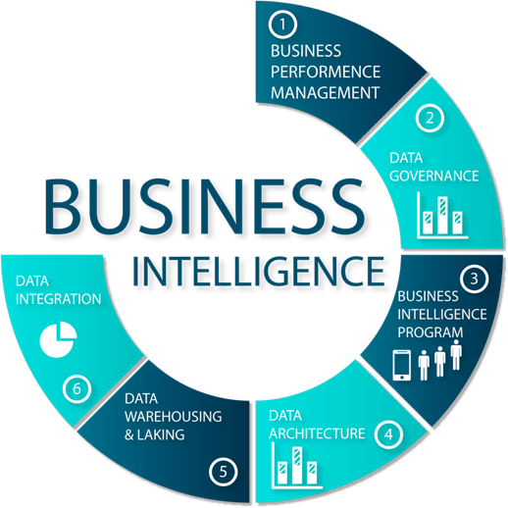

Figure : Business intelligence

# Example of Business intelligence

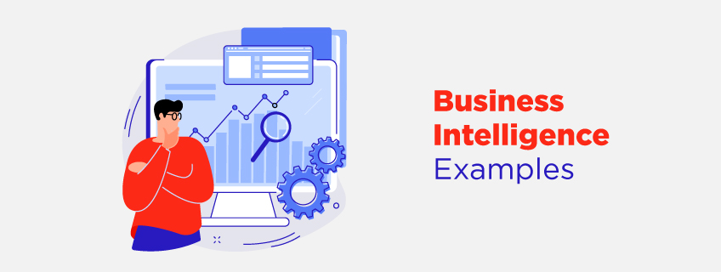

Figure : Example of business intelligence

## Decentralization

Every business division in an organization has its data requirements. For example, the inventory unit would need information only about the product availability, demand, and stocks. On the other hand, the sales department would require details about purchase patterns, buying histories, and more. Thus, BI allows the organization to decentralize the data and enable each department to explore its required data units. Moreover, you can also use an advanced form of distributed BI that provides an option to centralize the data for better security. (knowledgehut, 2022)

## KPI creation

Creating KPIs is one of the important BI examples that every organization uses to improve productivity. KPI stands for Key Performance Indicators. It tracks how close you are to your desired goal. KPIs are a great example of how business intelligence can contribute to ensuring that the team and its efforts deliver the best results. Participants in Visualization and Business Intelligence Courses learn how to create and research KPIs and keep every relevant team member aware of progress. (knowledgehut, 2022)

## Internal reporting for Teams

For the efficient functioning of an organization, the communication and data exchange between the teams should also be efficient. The reports generated by one team would get used by the other to carry on with their tasks. It is another example of BI as the tools under this domain help create the best and most reliable data lists, which other departments can use for making significant decisions. (knowledgehut, 2022)

## Automated Internal Structure

Automating tasks is another significant example of BI. You can incorporate the advanced tools and techniques in your current system that store all the data sourced from multiple sources and turn it into useful information. Any department wanting to access any data unit would only have to give the command and get the required information. There is no need to investigate the raw data sets and put efforts into segregating them, as the BI tool would automate the process to save a lot of your time.  (knowledgehut, 2022)

## Inventory Control

Gone are the days when organizations had to hire a large workforce in their inventory section to update the stock list. BI has taken over and has completely automated the tasks. There will be recorded data about what is present in your inventory. As you keep selling the products, the stock automatically gets updated. You would only have to check your data files whenever you need any information related to your inventory! It is one of the best examples of business intelligence in healthcare, as companies can keep track of their medicine stock. (knowledgehut, 2022)

## Better Market Analysis

One way to excel and stand ahead of your competitor is to analyze the market thoroughly. Learn the strategies your competitors follow and how their sales and revenue graphs respond to them. Moreover, you would also have to study what strategies you can adopt for your business and how they can help your business grow. BI helps you in proper market analysis by providing you with required data sets that give you awareness about market trends. You can study product sale reports, target audiences, and much more, which is helpful in decision-making. (knowledgehut, 2022)

# Tools for bi

## Microsoft Power BI

Microsoft Power BI is an interactive data visualization software product developed by Microsoft with a primary focus on business intelligence. It is part of the Microsoft Power Platform. Power BI is a collection of software services, apps, and connectors that work together to turn various sources of data into static and interactive data visualizations. Data may be input by reading directly from a database, webpage, PDF, or structured files such as spreadsheets, CSV, XML, JSON, XLSX, and SharePoint. (wikipedia, 2022)

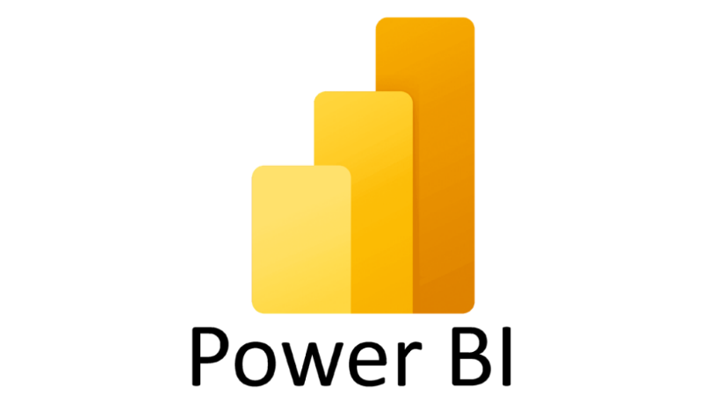

Figure : Microsoft Power BI

Benefits of Power BI:

* Data Visualization: Power BI enables you to create compelling visualizations, charts, graphs, and dashboards from your data. These visuals are interactive and provide insights that are easy to understand, making it simpler to communicate complex information. . (gestisoft, August 31, 2023)
* Data Connectivity: Power BI allows you to connect to a wide variety of data sources, including databases, cloud services, spreadsheets, and APIs. This flexibility enables you to bring together data from different sources for comprehensive analysis.
* Real-Time Dashboards: With Power BI's real-time capabilities, you can create live dashboards that display data updates as they happen. This is especially valuable for tracking key performance indicators and making data-driven decisions in real time.
* Data Transformation: Power Query, a component of Power BI, offers data transformation capabilities, allowing you to clean, reshape, and combine data from multiple sources before analysis. This helps ensure data accuracy and quality.
* Natural Language Queries: Power BI supports natural language queries, allowing users to ask questions about their data using everyday language. This feature makes data exploration more intuitive and accessible to users who may not have technical expertise.
* Data Modeling: The Power BI data modeling engine lets you create relationships between different data tables, define calculations, and create measures. This enables you to perform advanced calculations and build complex data models for in-depth analysis.
* Collaboration and Sharing: Power BI facilitates collaboration by allowing users to share reports and dashboards with colleagues and stakeholders. Reports can be published to the Power BI service or embedded in other applications, promoting information sharing.
* Mobile Accessibility: Power BI offers mobile apps for various platforms, allowing users to access reports and dashboards on smartphones and tablets. This ensures that decision-makers can stay informed even while on the go.

## Tableau

Tableau is a great business intelligence and data visualization tool used for reporting and analyzing huge volumes of data. It is an American company founded in 2003—in June 2019, Salesforce acquired Tableau. It helps users create various charts, graphs, maps, dashboards, and stories to visualize and analyze data, helping to make business decisions. Tableau has a lot of unique, interesting features that make it one of the most popular tools in the business intelligence (BI) field. (Biswal, Jul 21, 2023)



Figure : Tableau

Benefits of Tableau

* User-Friendly Interface: Tableau provides an intuitive and user-friendly interface that allows both technical and non-technical users to create compelling visualizations without the need for extensive programming or technical skills.
* Powerful Data Visualization: Tableau excels at creating powerful and interactive data visualizations. Users can easily represent complex datasets in the form of charts, graphs, maps, and dashboards, making it easier to identify patterns, trends, and insights.
* Connectivity to Various Data Sources: Tableau can connect to a wide variety of data sources, including databases, spreadsheets, cloud-based data, and big data sources. This flexibility in data connectivity enables users to analyze and visualize data from diverse sources in a unified platform.
* Real-Time Data Analysis: Tableau supports real-time data analysis, allowing users to connect to live data sources and update visualizations dynamically as the underlying data changes. This is particularly valuable for organizations that require up-to-the-minute insights.

Data Preparation and Cleaning: Tableau Prep, a component of Tableau, offers data preparation capabilities. Users can clean, shape, and transform their data within Tableau Prep before creating visualizations, streamlining the data preparation process.

## Python

Python is a high-level, object-oriented programming language. Python has a reputation as a beginner-friendly language, it handles most of the complexity for the user, allowing beginners to focus on fully grasping programming concepts rather than the details. small. Python is used for server-side web development, software development, mathematics, and systems scripting, and is popular for Rapid Application Development and as a scripting or binding language for linking together existing components due to its built-in, high-level data structures, dynamic typing, and dynamic binding. Additionally, Python's support of modules and packages facilitates modular programs and code reuse. Python is an open source community language so many independent programmers are continuously building libraries and functions for it. (Teradata, 2022)



Figure : Python

## Compare Power BI, Tableau and Python

|  |  |  |  |
| --- | --- | --- | --- |
| Factor | Python | Power BI | Tableau |
| Programming Language | Python | Data Analysis Expressions (DAX),  M (Power Query) | R, SQL, Python, Java, C++, C#, TypeScript/JavaScript, etc |
| Data integration | Has integration with various libraries and APIs to work with different data sources | Integration with multiple data sources from Microsoft and third parties | Tableau collation language Python, R |
| Code Intergration | Available | Limited support for custom code integration | Available (Python and R) |
| Data visualization | Easily create intuitive  dashboards and  reports | Provides intuitive  charts and dashboards | Using libraries for  visualization |
| Performance | Depends on data size and libraries used | Good performance, optimized for red-time analysis | Good performance, optimized for red-time analysis |
| Pricing | Free | Offers free version and paid version with extended fixtures | Offers free version and paid version with extended fixtures |

# BI Techniques

There are several business intelligence techniques companies can put to use to gain valuable insights to inform decision-making. Here’s a look at the most common BI techniques. (CallMiner, September 05, 2019)

## Predictive Modeling

Predictive modeling is a BI technique that utilizes statistical techniques to create models that could be used in forecasting probabilities and trends. With predictive modeling, it is possible to predict the value for a particular data item as well as the attributes using multiple statistical models. (CallMiner, September 05, 2019)

## Analytics

Analytics is a business intelligence technique that involves the study of available data to extract meaningful insights and trends. This is a popular BI technique since it lets businesses deeply understand the data they have and drive ultimate value with data-driven decisions. For instance, a marketing organization can use analytics to establish the customer segments that are highly likely to convert to new customers, and call centers leverage speech analytics to monitor customer sentiment, improve the customer experience, and for quality assurance purposes, just to name a few. (CallMiner, September 05, 2019)

## OLAP

Online analytical processing is a technique for solving analytical problems with different dimensions. The most important value in OLAP is its multidimensional aspect that lets users identify problems from different perspectives. OLAP could be used to complete tasks such as budgeting, CRM data analysis, and financial forecasting. (CallMiner, September 05, 2019)

## Data Mining

Data mining is a technique for discovering patterns in huge datasets and often incorporates database systems, statistics, and machine learning to find these patterns. Data mining is an integral process for data management as well as the pre-processing of data since it ensures appropriate data structuring. End users could also use data mining to create models that reveal these patterns. For instance, a business could mine CRM data to predict which leads will most likely buy a certain solution or product. (CallMiner, September 05, 2019)

## Model Visualization

The model visualization technique is used to transform the discovered facts into histograms, plots, charts and other visuals that aid in proper interpretation of the insights. (CallMiner, September 05, 2019)

DESIGN A BUSINESS INTELLIGENCE TOOL, APPLICATION OR INTERFACE THAT CAN PERFORM A SPECIFIC TASK TO SUPPORT PROBLEM-SOLVING OR DECISION-MAKING AT AN ADVANCED LEVEL (P4)

# Python analysis

Because the market is fiercely competitive and customers are increasingly scarce, we realize that the company should have new strategic plans to improve the company's business situation. Therefore, we have collected reviews of good books from customers with the aim of recommending to customers books that are worth reading because customers are scarce because most of them are hesitant while buying books. Therefore, this will help customers identify the books they want to buy and buy more books. In addition, we will also know which books are popular with customers so we can import and market them more easily to customers.

## Import libraries

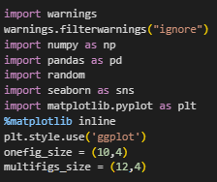

Figure : Import libraries

## Import Dataset

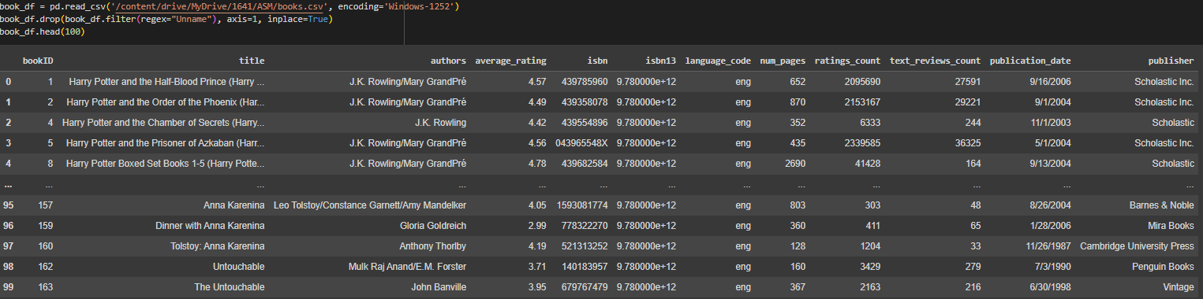

Figure : Import dataset

## Explain attribute information

|  |  |
| --- | --- |
| Columns | Meaning |
| bookID | Contains the unique ID for each book |
| title | Contains the titles of the books |
| authors | Contains the author of the particular book |
| average_rating | The average rating of the books, as decided by the users |
| isbn | ISBN(10) number, tells the information about a book - such as edition and publisher |
| isbn13 | The new format for ISBN, implemented in 2007. 13 digits |
| language_code | Tells the language for the books |
| num_pages | Indicates the number of pages in a book |
| rating_count | Contains the number of ratings given for the book |
| test_review_count | Has the count of reviews left by users |
| dublication_date | The date on which a book or magazine is published |
| publisher | Contains the publisher of the particular book |

## Describe data

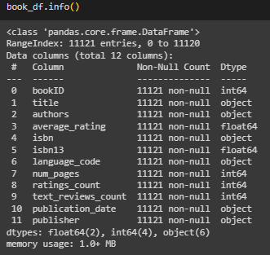

Figure : Describe data

* Data has 12 columns and 11121 rows:
* No missing data.
* There are 6 columns of qualitative type.
* There are 6 columns of quantitative type.
* No null value.

## Duplicate Value

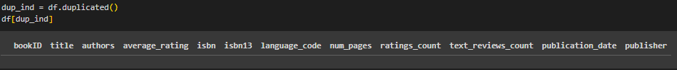

Figure : Duplicate value

* Our data has no duplicates.

## Describe statistics

This description table is used to view some basic statistical details such as count, mean, standard deviation, min and max of a data frame or a series of numeric values.

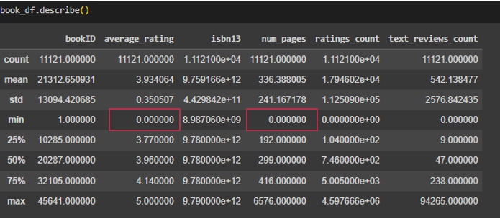

Figure : Describe statistics

* Depending on the data type, some values ​​do not match logically. As here, the columns average_rating and num_pages have a min of 0. However, the minimum value displayed is 0, there may be some customers who do not rate or have missing data.

Therefore, we must perform the data cleaning step to be able to properly analyze the data.

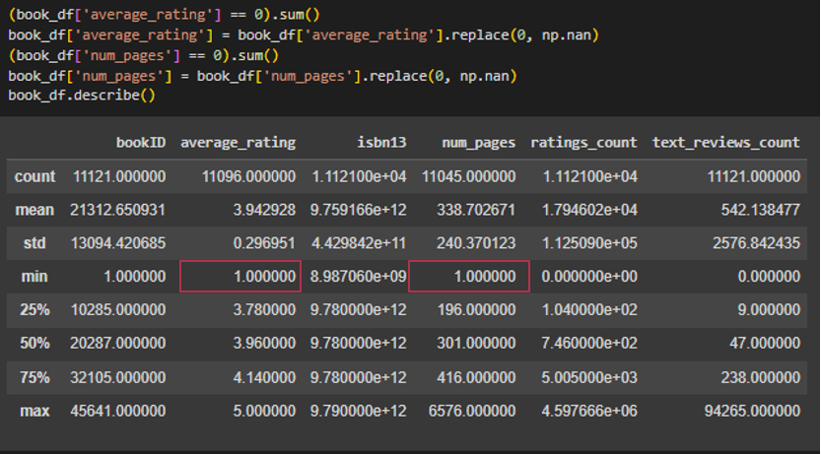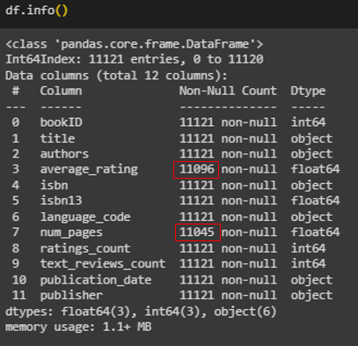

Figure : Clean data

* Checking the updated statistical data now shows the minimum value is 1, and the values ​​in the table have also been cleaned up. So we can easily see the average rating ranges from 1 to 5 points, with 4 being the most in the list.

## Uni - Variable

This chart shows the frequency of average ratings of the books on the list.

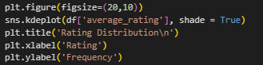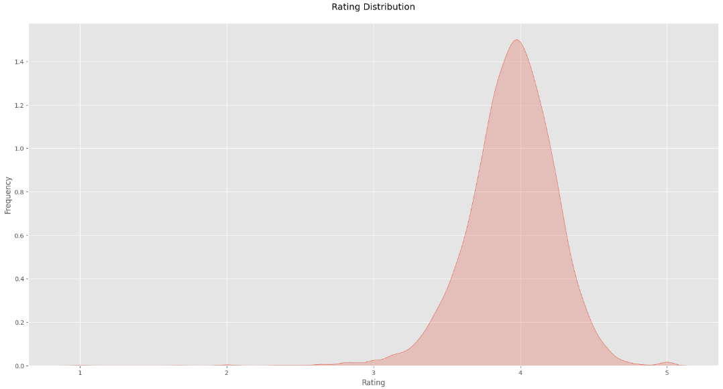

Figure : Rating distribution

* Through the chart above, we can see that the average rating of the books on the list ranges from about 3 to 5 points. Among them, the frequency of about 4 points appears the most. This means that the ratings are generally positive.

This chart represents the sum of the languages of the books included in the list.

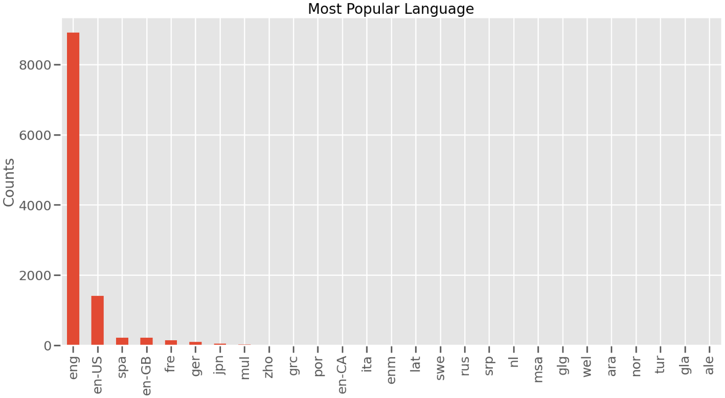

Figure : Most popular language

* We can see from the chart that books written in English make up the largest number on the list, perhaps because it is a popular language.

## Bi - Variable

This chart is used to find the languages that make up the most books with the highest average ratings.

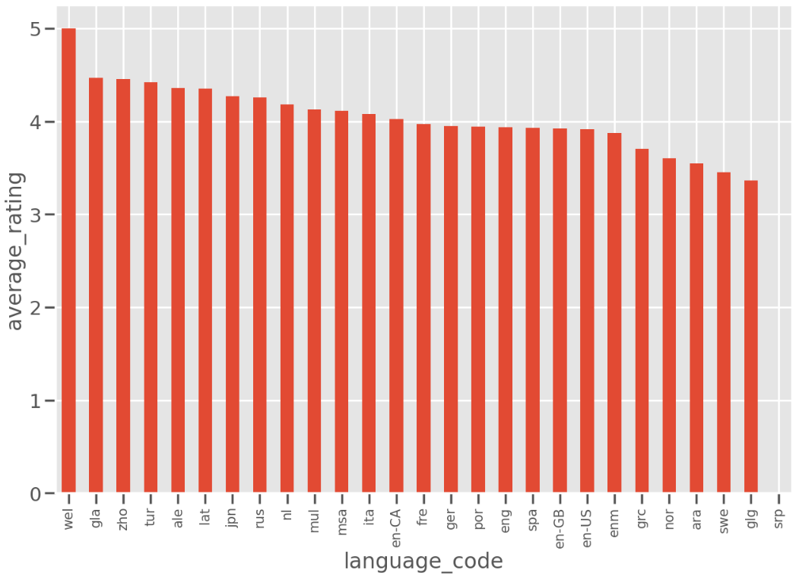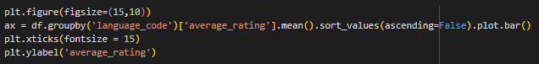

Figure : Languages with the most books with the highest average ratings

* The chart shows that Welsh is the language that has the largest number of books with a high average rating. Therefore, when comparing the chart above and this chart, we can see that the English language dominates but there are not many books ranked highly in the Welsh language.

These charts focus on recommending authors to users, respectively showing the top authors with the most books and the top authors with the most books with the highest average rating.

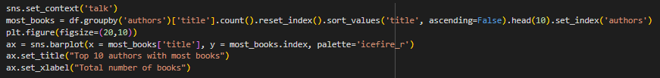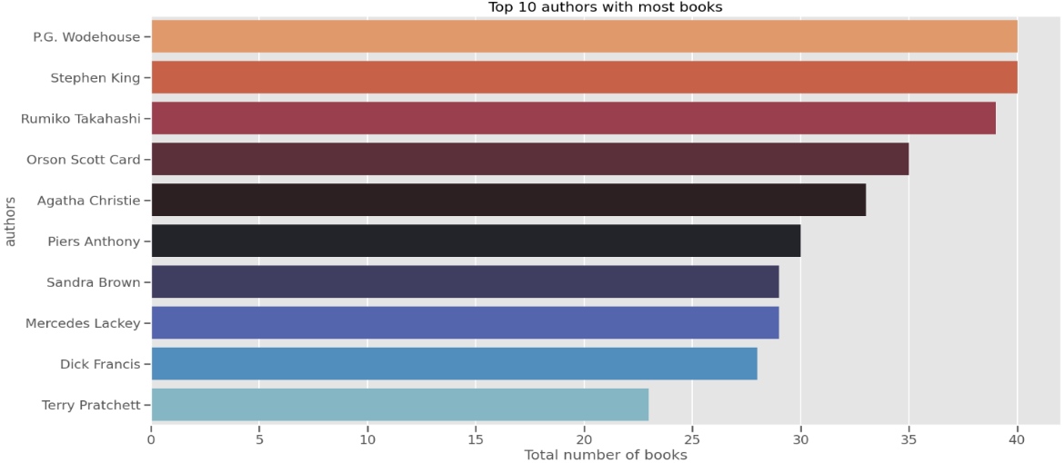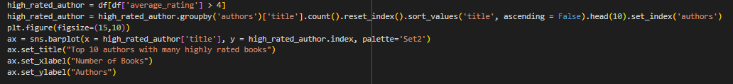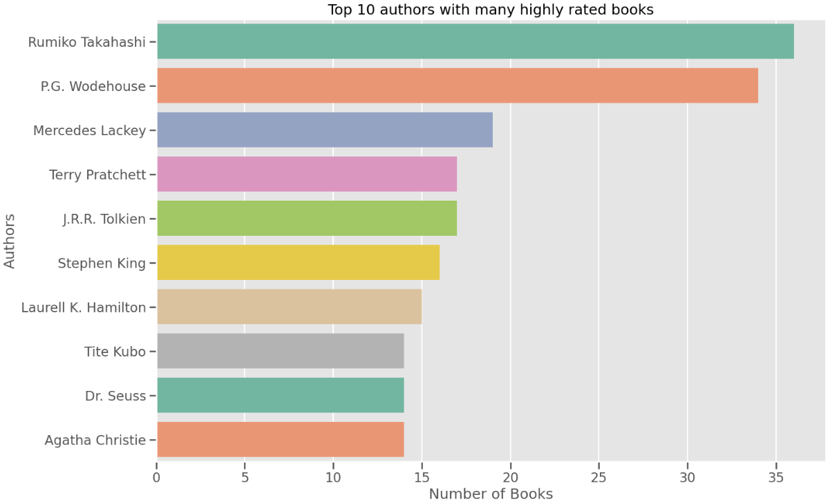

Figure : Compare two charts: Authors with most books and authors with many highly rated books

* Looking at these two charts, we can see that the authors with many books with high average ratings are not necessarily the authors with the most books. Through it we can see the works of authors Rumiko Takahashi and P.G. Wodehouse's are undoubtedly bestsellers.

The charts focus on recommending books directly to users, respectively showing the top books with the most votes and the top rated books.

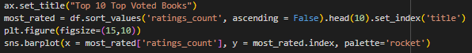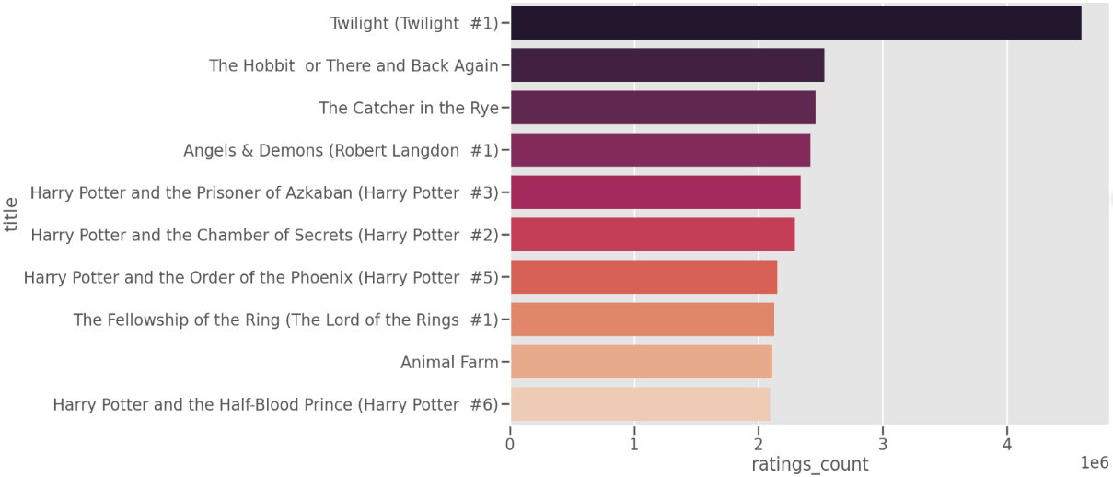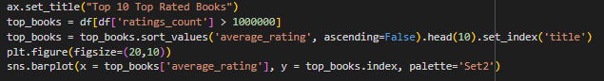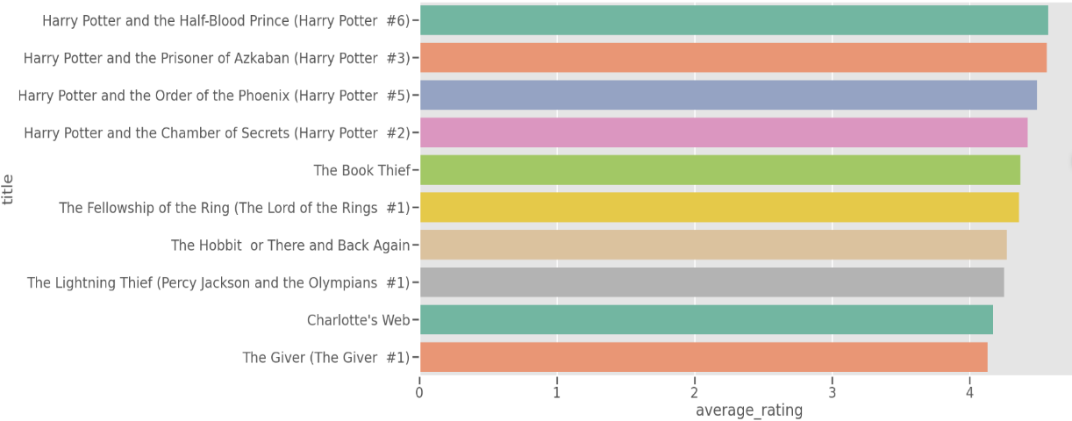

Figure : Compare two charts: Top voted books and top rated books

* A book considered highly rated must include many votes and a high average ranking score. Looking at these two charts, we can see that some of the most voted books are not the highest rated and vice versa. Through this, it can be seen that the Harry Potter series has many votes and a rating of over 4. Therefore, they will sell very well.

# Power BI

Python has a steep learning curve and can be daunting. Therefore, I use Power BI which provides a user-friendly platform for my data visualization and business intelligence.

## Import Dataset

After selecting the get data function on the toolbar, click text/csv in the dialog box that appears and press the connect button to take me to my folder. Then I select the csv file, the dialog box displays as below and click load.

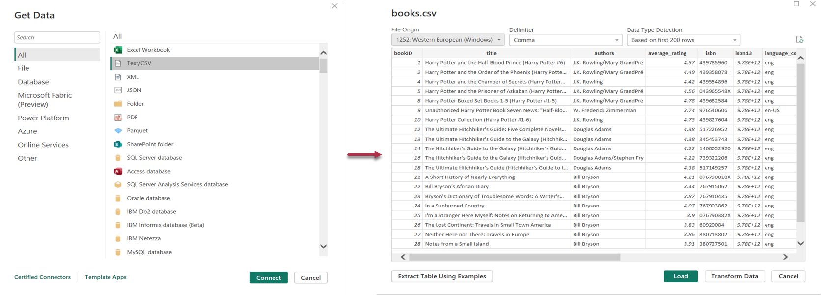

Figure : Import dataset

After successfully loading the list, I can select the aggregated data next to it and use tools to visualize my data.

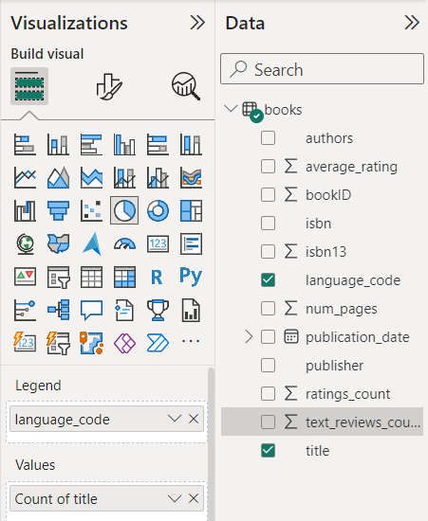

Figure : Charts for data visualization

## Result

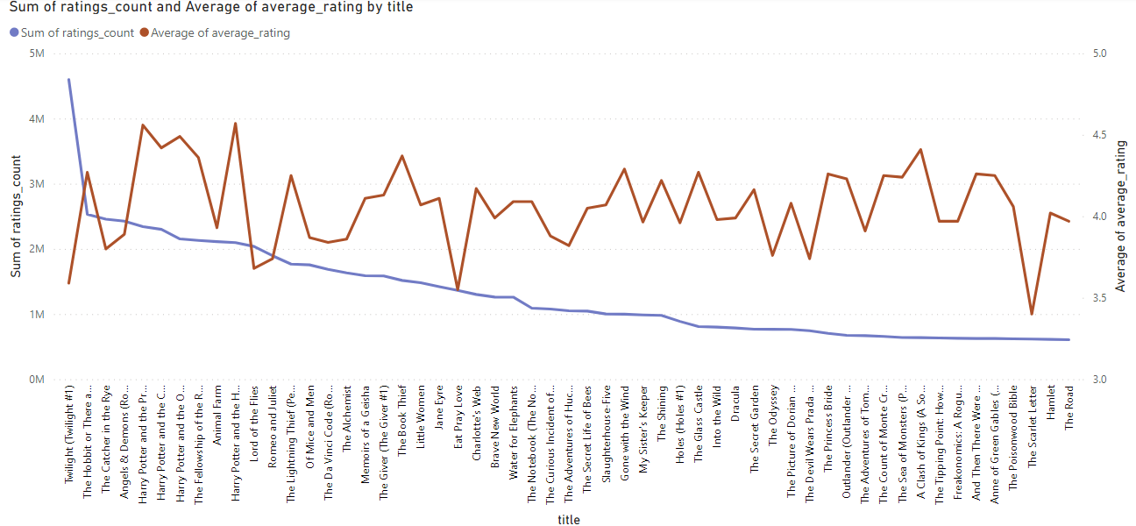

Figure : Rating counts and average ratings of books

* Looking at the chart, we can see the average votes and ratings of each book clearly displayed. Thus, we can compare the book Twilight and the book The Hobbit or There and Back Again, we can see that Twilight's votes are higher than the other book's, but its average rating is only over 3 points. While The Hobbit or There and Back Again has a score of more than 4. In conclusion, The Hobbit or There and Back Again may be more worth reading.

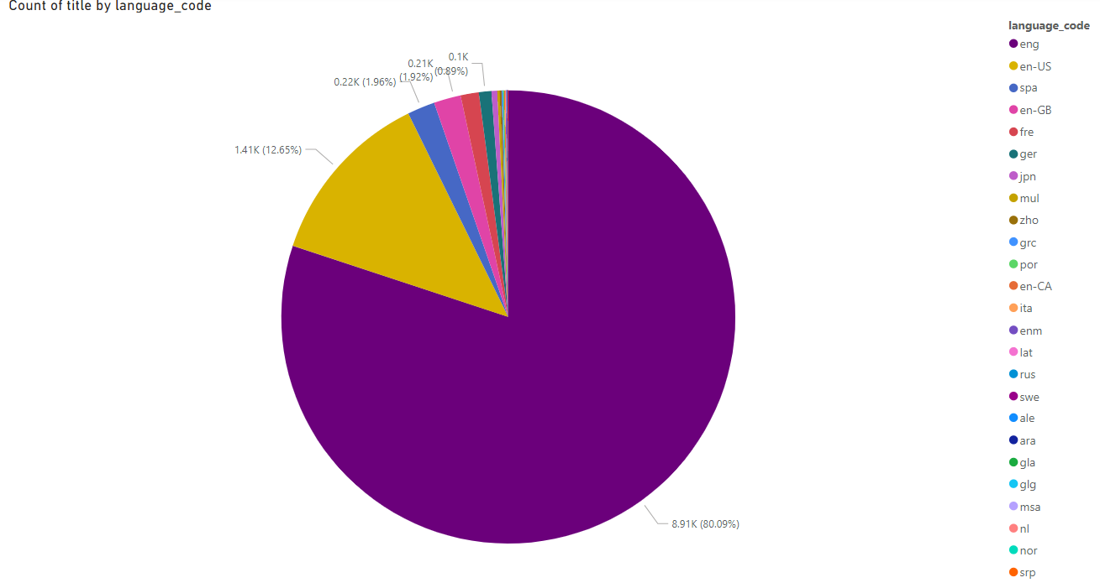

Figure : Language codes of books

* Looking at the chart this time, we can clearly see that the English language accounts for about 80% of the total languages ​​on the list.

# Tableau dashboard

In addition to Power BI, I also use Tableau tools for design and data analysis. It is user-friendly, easy to interact with, and has many chart types for much better data visualization.

## Import Dataset

After selecting the new data source function on the toolbar, a dialog box will appear as shown for me to import my csv file.

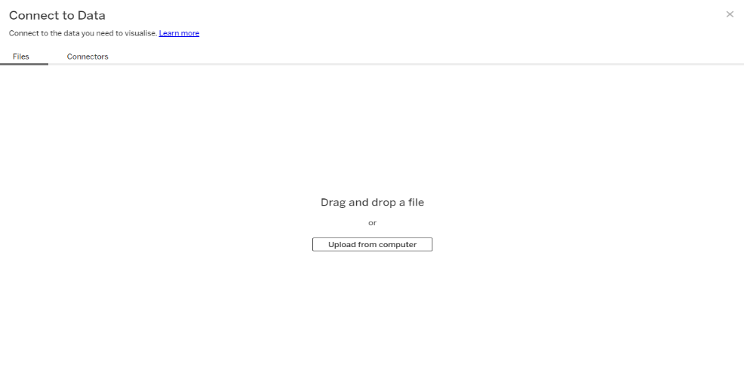

Figure : Import dataset

After waiting for loading to complete, the data will be updated in the table as shown in the image below.

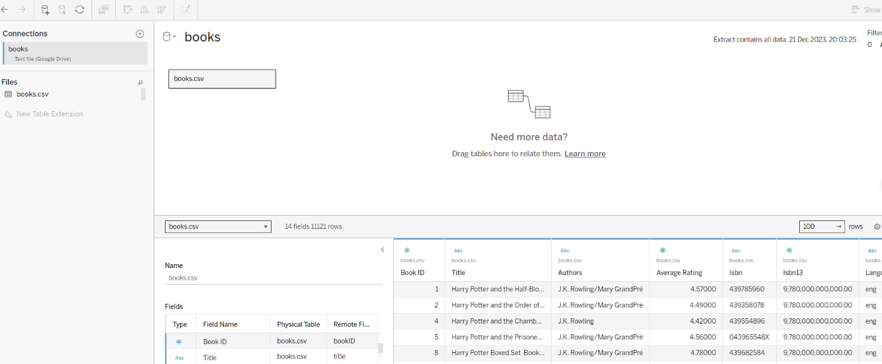

Figure : Data imported to tableau

Looking at the left corner of the screen, there will be buttons: Create new sheet, create new dashboard, create new story and I only use two buttons to create new sheet and dashboard. In particular, sheet lets me visualize data with charts and dashboard lets me summarize my sheets.

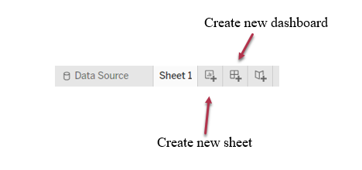

Figure : Buttons

## Result

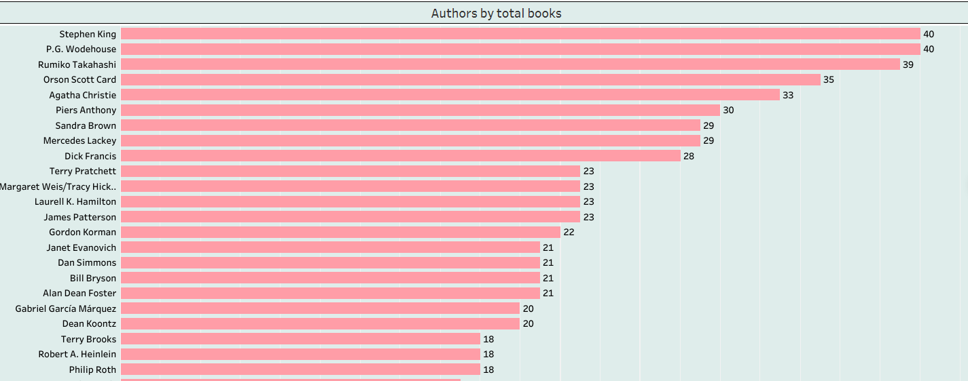

Figure : Authors by total books

* The data has been visualized with a chart that easily shows the authors with the most books. Among them, P.G.Wodehouse and Stephen King are the authors with the most books.

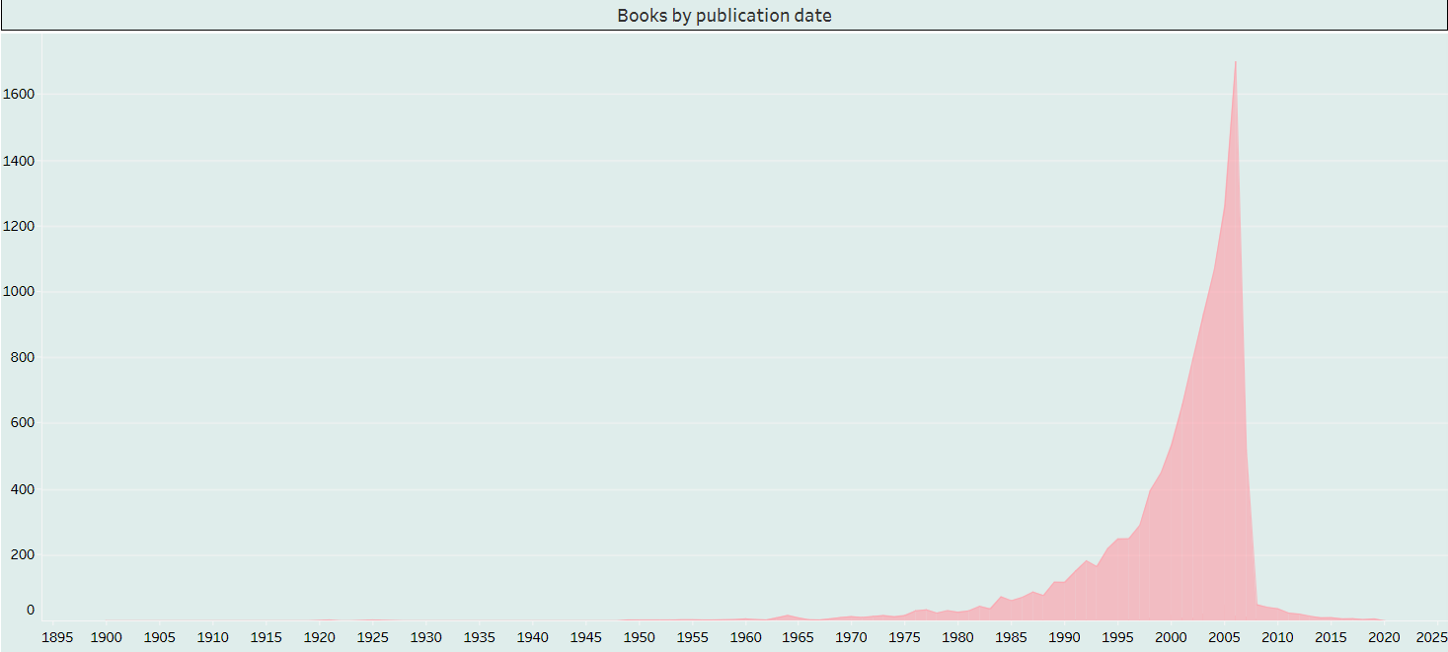

Figure : Books by publication date

* The data has been visualized with a chart that easily shows the year in which the most books were published. Among them, from 2000 to 2005, the author was the most productive.

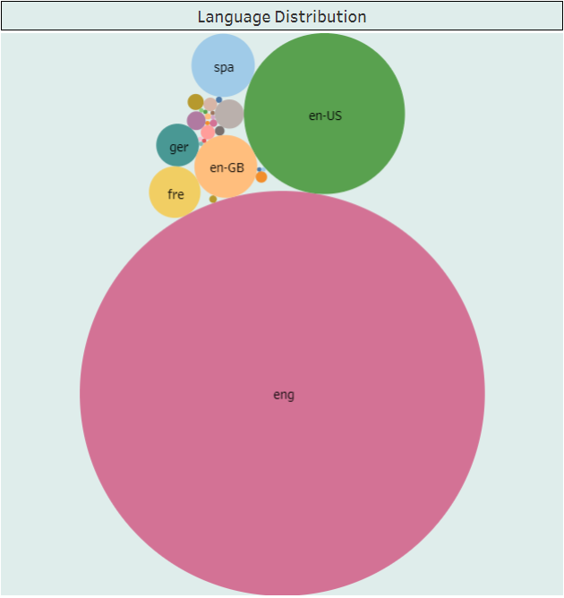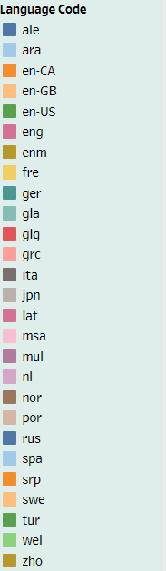

Figure : Language distribution

* The data has been visualized with a chart that easily shows that English is the most popular language among the languages ​​on the list.

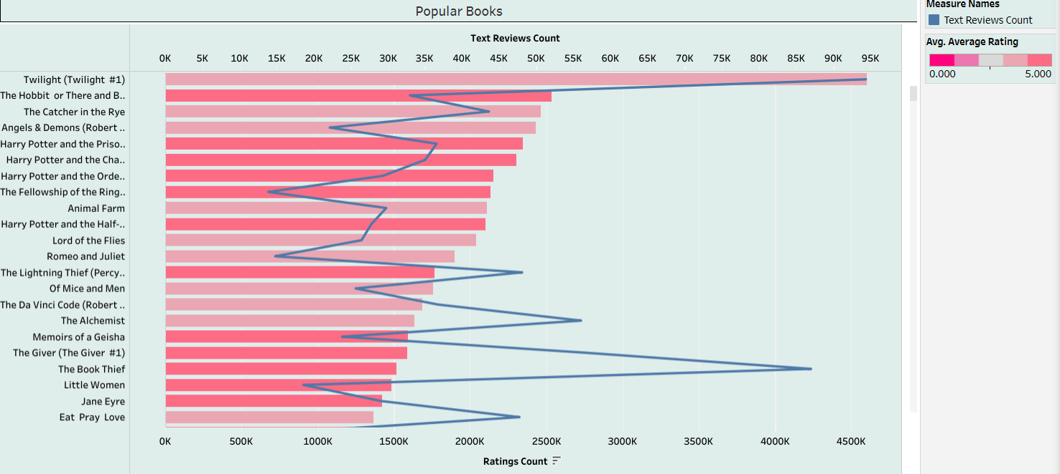

Figure : Popular books

* The data has been visualized with a chart that easily shows the votes and text ratings of each book. It can be seen that the book Twilight is the one that receives the most attention.

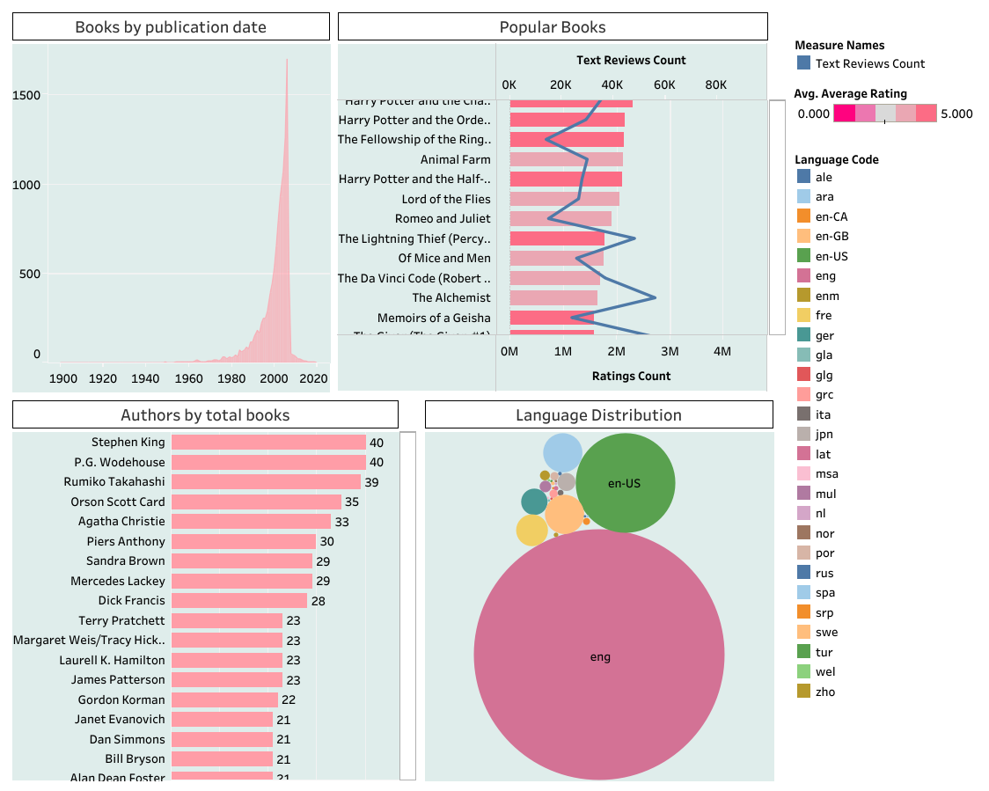

Figure : Dashboard

# User evaluation survey

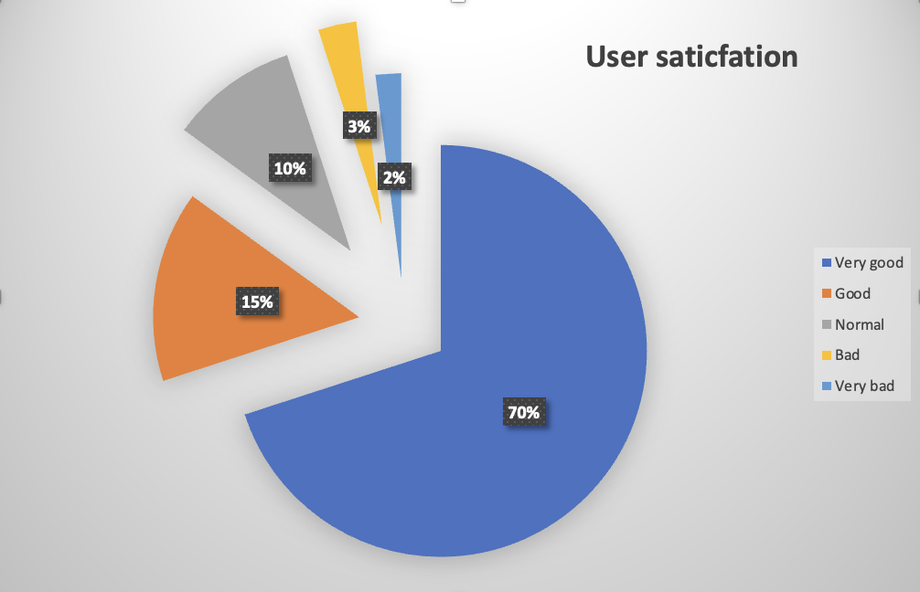

Figure : User satisfaction about Tableau

* Through user surveys showed, Tableau application is rated very good by users, accounting for 70%. The remaining 30% is divided equally among the following reviews: 15% for Good, 10% for Normal, 3% for Bad, and finally 2% for Very bad.

DISCUSS HOW BUSINESS INTELLIGENCE TOOLS CAN CONTRIBUTE TO EFFECTIVE DECISION-MAKING (P5)

# Business Intelligence

Business Intelligence (BI) is a technology-based process for analyzing data and providing useful information that helps executives, managers, and employees make informed business decisions. Our company's goal of using BI strategy is to drive better business decisions, increase revenue, improve operational efficiency, and gain a competitive advantage over business competitors. To achieve that goal, in addition to BI, we combine analytics, data management and reporting tools along with a variety of methods for data management and analysis. (Stedman, 2022)

## Business Intelligence system

A Business Intelligence (BI) system is a set of technologies, processes, and tools that help organizations collect, analyze, and present business data for better decision support. The main goal of a BI system is to convert raw information into meaningful and actionable insights. Below are the main components and edges of a typical Business Intelligence system:

* ***Data sources:***
* ***Data Internal***: This includes data generated within the organization, such as sales data, customer information, and key financial records.
* ***External data:*** Data from external sources, such as market trends, industry reports, and economic indicators, can be combined for clearer analysis.
* **Data warehouse:** Centralized storage for large volumes of data, often from disparate sources, to facilitate efficient querying and reporting. The repository stores historical data and is optimized for analytical processing.
* ***ETL (Export, transform, load):*** The process of extracting data from the system source, converting the data to the appropriate format, and loading the data into the data warehouse for analysis.
* ***Data analysis***: BI systems provide tools for data analysis, including querying, reporting, and especially online data visualization. Users can explore the data to identify direction, patterns, and outliers.
* ***Visual chemical data:*** Present data visually through charts, graphs, dashboards, and other pre-visual elements to make complex information more accessible and understandable.
* ***OLAP (Online Analytical Processing):*** OLAP allows users to analyze maximum data interactively. It allows users to access depth, scroll up, and rotate data for deeper insights.
* ***Expected analysis:*** System BI can combine prediction and model analysis to forecast trends and corresponding outcomes based on historical data.
* ***Security and administrative data:*** Implement measures to ensure the security and management of administrative data, including user access control, data encryption, and regulatory compliance.

A well-developed BI system can benefit competitive organizations by enabling data-driven decision-making and improving overall business performance. It empowers users at every level of the organization to make informed choices based on reliable and relevant information.

## Benefits Business Intelligence

Data-driven Decision Making: BI provides insights derived from data analysis, helping organizations make informed decisions based on facts and trends rather than relying solely on intuition or past experiences.

Improved Strategic Planning: BI tools enable organizations to assess historical data, identify trends, and forecast future performance. This aids in the development of more effective strategic plans and long-term goals.

Increased Operational Efficiency: By streamlining data collection, analysis, and reporting processes, BI helps in reducing the time and effort required for routine operational tasks. This, in turn, improves overall efficiency.

Enhanced Visibility into Performance: BI dashboards and reports provide a clear and visual representation of key performance indicators (KPIs), allowing stakeholders to monitor and evaluate performance metrics in real-time.

Dashboard: A dashboard is a collection of charts, tables, and other visual elements organized on a single page. Dashboards help users better understand business performance and learn trends and relationships between key metrics.

# Tools for BI

## Power BI

Microsoft Power BI is an interactive data visualization software product developed by Microsoft with a primary focus on business intelligence. It is part of the Microsoft Power Platform. Power BI is a collection of software services, apps, and connectors that work together to turn various sources of data into static and interactive data visualizations. Data may be input by reading directly from a database, webpage, PDF, or structured files such as spreadsheets, CSV, XML, JSON, XLSX, and SharePoint. (wikipedia, 2022)

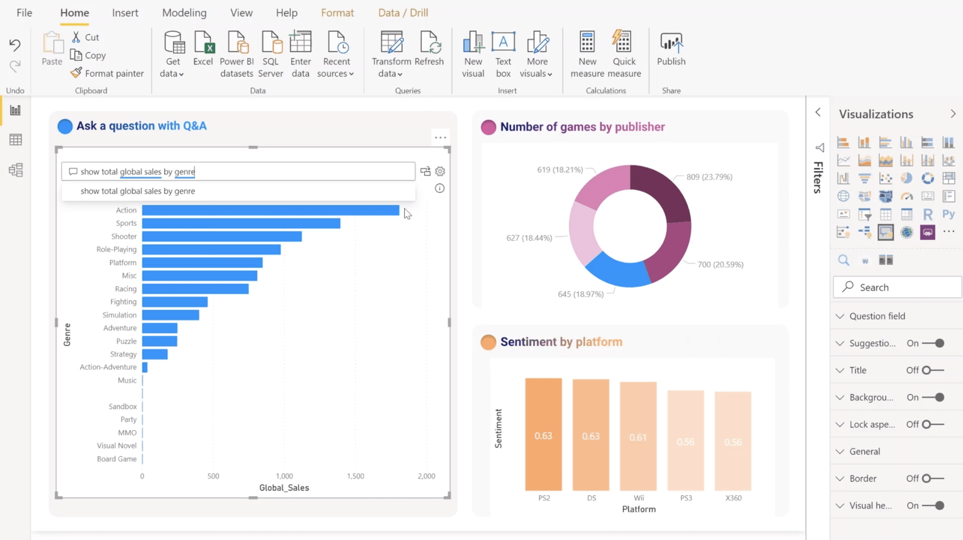

Figure : Power BI

**Benefits of Power BI:**

* ***Data Visualization:*** Power BI enables you to create compelling visualizations, charts, graphs, and dashboards from your data. These visuals are interactive and provide insights that are easy to understand, making it simpler to communicate complex information. (gestisoft, August 31, 2023)
* ***Data Connectivity:*** Power BI allows you to connect to a wide variety of data sources, including databases, cloud services, spreadsheets, and APIs. This flexibility enables you to bring together data from different sources for comprehensive analysis.
* ***Real-Time Dashboards:*** With Power BI's real-time capabilities, you can create live dashboards that display data updates as they happen. This is especially valuable for tracking key performance indicators and making data-driven decisions in real time.
* ***Data Transformation***: Power Query, a component of Power BI, offers data transformation capabilities, allowing you to clean, reshape, and combine data from multiple sources before analysis. This helps ensure data accuracy and quality.
* ***Natural Language Queries:*** Power BI supports natural language queries, allowing users to ask questions about their data using everyday language. This feature makes data exploration more intuitive and accessible to users who may not have technical expertise.
* ***Data Modeling:*** The Power BI data modeling engine lets you create relationships between different data tables, define calculations, and create measures. This enables you to perform advanced calculations and build complex data models for in-depth analysis.
* ***Collaboration and Sharing:*** Power BI facilitates collaboration by allowing users to share reports and dashboards with colleagues and stakeholders. Reports can be published to the Power BI service or embedded in other applications, promoting information sharing.
* ***Mobile Accessibility:*** Power BI offers mobile apps for various platforms, allowing users to access reports and dashboards on smartphones and tablets. This ensures that decision-makers can stay informed even while on the go.

## Tableau

Tableau is a great business intelligence and data visualization tool used for reporting and analyzing huge volumes of data. It is an American company founded in 2003—in June 2019, Salesforce acquired Tableau. It helps users create various charts, graphs, maps, dashboards, and stories to visualize and analyze data, helping to make business decisions. Tableau has a lot of unique, interesting features that make it one of the most popular tools in the business intelligence (BI) field. (Biswal, Jul 21, 2023)

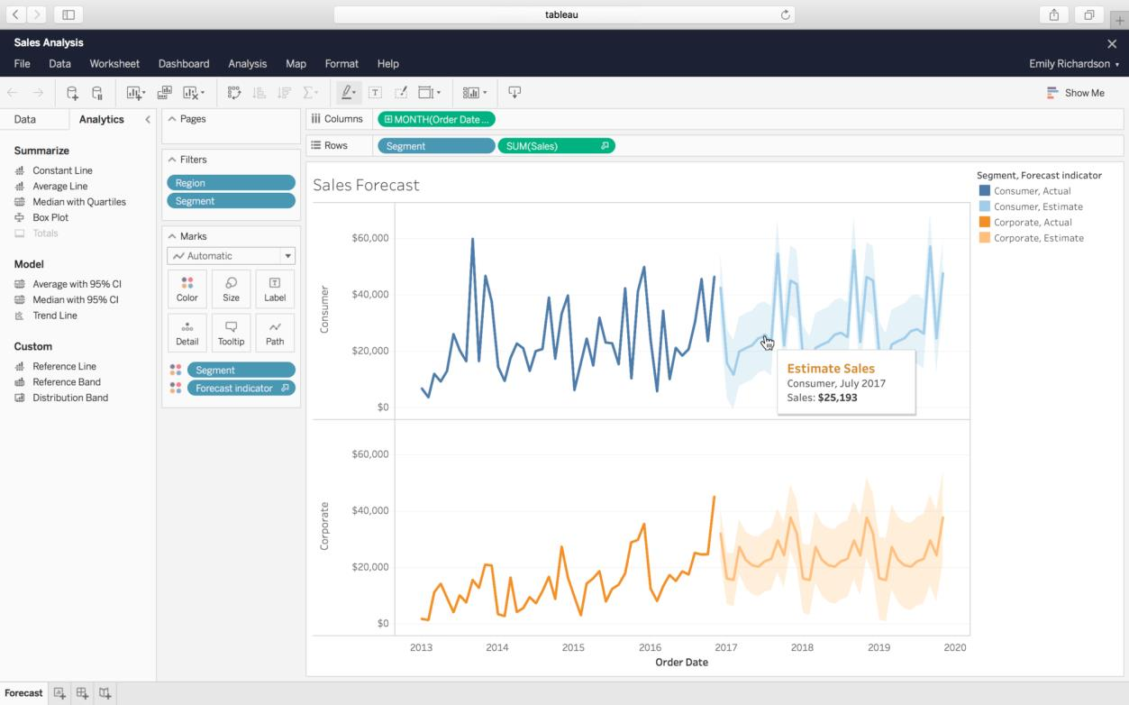

Figure : Tableau

**Benefits of Tableau**

* ***User-Friendly Interface:*** Tableau provides an intuitive and user-friendly interface that allows both technical and non-technical users to create compelling visualizations without the need for extensive programming or technical skills.
* ***Powerful Data Visualization:*** Tableau excels at creating powerful and interactive data visualizations. Users can easily represent complex datasets in the form of charts, graphs, maps, and dashboards, making it easier to identify patterns, trends, and insights.
* ***Connectivity to Various Data Sources:*** Tableau can connect to a wide variety of data sources, including databases, spreadsheets, cloud-based data, and big data sources. This flexibility in data connectivity enables users to analyze and visualize data from diverse sources in a unified platform.
* ***Real-Time Data Analysis:*** Tableau supports real-time data analysis, allowing users to connect to live data sources and update visualizations dynamically as the underlying data changes. This is particularly valuable for organizations that require up-to-the-minute insights.
* ***Data Preparation and Cleaning:*** Tableau Prep, a component of Tableau, offers data preparation capabilities. Users can clean, shape, and transform their data within Tableau Prep before creating visualizations, streamlining the data preparation process.

## Python

Python is a high-level, object-oriented programming language. Python has a reputation as a beginner-friendly language, it handles most of the complexity for the user, allowing beginners to focus on fully grasping programming concepts rather than the details. small. Python is used for server-side web development, software development, mathematics, and systems scripting, and is popular for Rapid Application Development and as a scripting or binding language for linking together existing components due to its built-in, high-level data structures, dynamic typing, and dynamic binding. Additionally, Python's support of modules and packages facilitates modular programs and code reuse. Python is an open source community language so many independent programmers are continuously building libraries and functions for it. (Teradata, 2022)

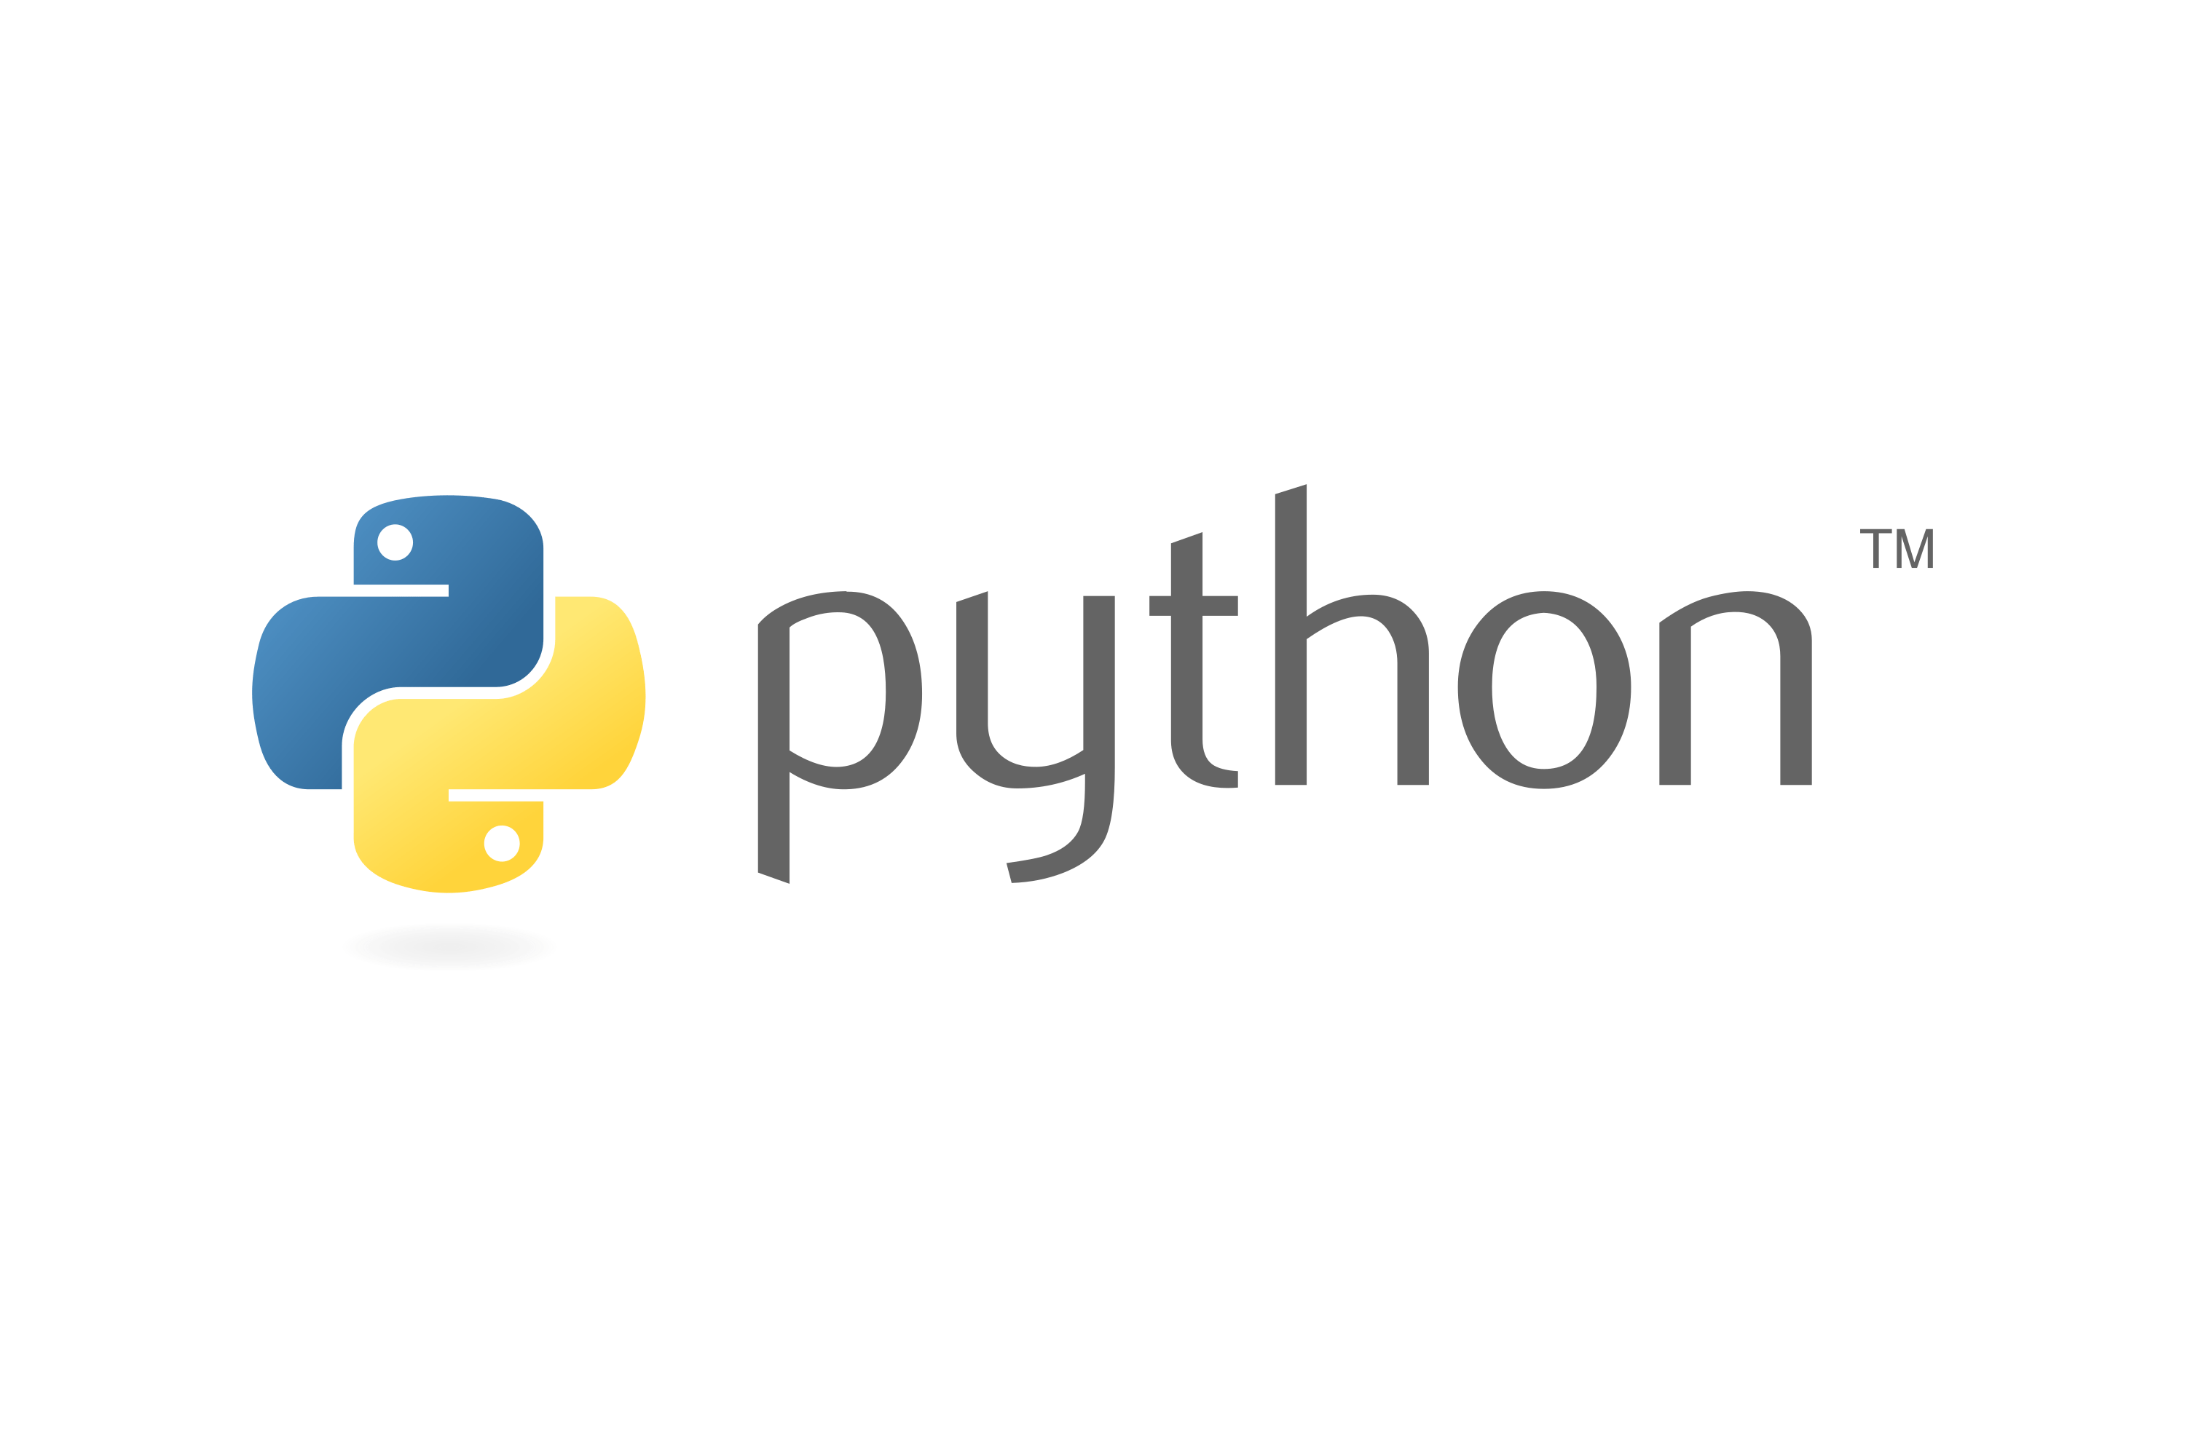

Figure : Python

* ***Machine learning integration:*** Python has become a popular language for machine learning, and libraries like scikit-learn provide many machine learning algorithms and tools. This integration enables a seamless transition from data analysis to building predictive models.
* ***Compatibility with big data tools:*** Python integrates well with big data tools and frameworks. Libraries like PySpark enable data analysts to work with large data sets using Apache Spark, and tools like Dask provide parallel computing capabilities for analytics.
* ***Open source and cross-platform:*** Python is open source and freely available, making it accessible to a wide audience. It's also cross-platform, meaning it can run on Windows, macOS, and Linux, giving users flexibility.
* ***Flexibility and scalability:*** Python is a general-purpose programming language, and its flexibility allows for many applications beyond data analysis. It can be used for web development, automation, scripting, and more.

Python integrates seamlessly with databases, cloud services, and other tools commonly used in the data analysis process. This makes it easy to import and export data and collaborate with different tools and platforms.

Overall, Python's strengths in libraries, community support, and ease of use make it a popular choice for data analysts and scientists around the world. It provides a solid foundation for various aspects of data analysis, from data cleaning and exploration to machine learning and visualization.

# BI tools can contribute to effective decision-making

Python, Power BI and Tableau were used to create and build a dashboard that displays charts and diagrams of my company's activities, as I pointed out in the previous section. As a result, my business now has visual diagrams that allow us to evaluate and analyze data from multiple sources in real-time, allowing us to make informed decisions that can increase productivity and profitability. Using BI tools in the book development business has many benefits that can significantly impact a business's bottom line, especially when it comes to decision-making.

Improved operational efficiency is one of the most important advantages of applying business tools in the book development business. Because the company is competing with many other businesses. We tap into customer psychology with many customers not knowing which books to choose to read. So we created charts showing which books are most frequently purchased and read. Give objective reviews of those books. And recommend good books to users so they can easily choose and buy more books.

Generally, we use business technology to track interactions between customers and books to provide customer reviews and ratings of books. These technologies enable our business to customize our services to fit customer needs by providing access to data about consumer behavior and preferences.

This is because we have divided the selections into clearly different sections, such as predicting the most purchases, and the most popular types of books, etc. Realizing that these factors are interdependent is key. Therefore, by using BI tools, we can quickly integrate them to create an overview of business operations and make predictions about consumer patterns, which directly affect corporate decision-making.

Business intelligence tools can also assist in the financial management of businesses. These technologies help my organization make informed decisions that can improve financial performance by providing access to sales, cost, and profit data. To manage spending and find ways to save costs, such as identifying the books with the highest purchases and votes that customers choose to be able to meet consumer needs as quickly as possible, we Can specifically use business tools.

In short, the use of business technology can significantly influence the way my retail bookstore makes decisions. My company, using the tools of the trade, will be better positioned to prosper and grow in the coming years as the book business becomes even more competitive.

EXPLORE THE LEGAL ISSUES INVOLVED IN THE SECURE EXPLOITATION OF BUSINESS INTELLIGENCE TOOLS (P6)

Huge, diverse data sets are frequently employed to explain data. Data may also originate from other sources, such as social networking, internet shopping, and data from approved Facebook users. No matter the time or place, everything around us is always producing data. Numerous sources deliver data at high speeds, in big numbers, and with varying degrees of complexity. Analysis abilities are required to extract useful information from massive amounts of data.

To make better decisions, all firms must compute the conversion of massive amounts of complicated data into information. Big data analytics is the process of gathering, synthesizing, and analyzing data in order to discover numerous pertinent information. Big data analytics may assist businesses in more effectively evaluating data and identifying data that will improve your company's decision-making skills.

Businesses must also consider the many legal issues that come from the safe usage of business intelligence (BI) technologies. As a result, legal departments in firms must integrate matter management, electronic reporting technologies, and data analytics to successfully maximize data privacy, security, and compliance.

Legal Issues:

# Data Privacy

Data privacy is a crucial legal concern in the safe deployment of BI technology. Before collecting and analyzing data utilizing technology, businesses must ensure that they are in compliance with all applicable privacy standards and regulations. Compliance with data protection regulations, such as the General Data Protection Regulation (GDPR), as well as industry-specific requirements, such as the FMCSA guidelines, is required. Businesses must ensure that they are following the law and ethical norms when using BI technologies to make choices that affect individual persons or groups. Furthermore, when gathering adequate data from consumers and staff, it is critical to ensure that the information is only obtained, used for what it was meant for, and kept and destroyed in accordance with approved standards. (Linkedin, 2023)

# Data Security

Businesses must take care to protect the data they collect and analyze with BI technology from illegal access or exposure. In general, data may be stolen in two ways: by an employee who is given access and then reveals it to anybody outside the firm, or via a technological fault. Greater security measures should be put in place at the company's data warehouse to prevent information from falling into the wrong hands. Businesses can establish appropriate access controls to protect their data. This means restricting access to information to only those employees who need it to do their duties. (Linkedin, 2023)

Businesses, for example, can implement multifactor authentication to ensure that only authorized users have access to essential data, or they can designate several user roles with varying levels of data access.

Furthermore, firms must be prepared to respond to security incidents such as data breaches, which may threaten the privacy of sensitive data. This includes implementing appropriate data security measures such as intrusion detection systems, firewalls, and encryption, as well as having a plan in place to manage occurrences and notify affected parties and regulatory organizations. (Linkedin, 2023)

# Control over data

Data ownership may be competitive because data control data owners can be abused and shared. The ownership of analysis-related data is also critical. Data permissions are commonly provided in security and TOS rules for websites, online services, and mobile applications. Traditional written contracts can be used in business-to-business transactions.

For example: In an intelligent business application, an IoT provider and its customer can use a signed contract. Joint ownership is a platform that acts as a mediator in the distribution of ownership in various enterprises. for business transactions. (Linkedin, 2023)

# Legal Liability

As the legal industry advances, practices that use business intelligence will be better positioned to prosper in an increasingly data-driven environment. When utilizing BI technologies, businesses must be cognizant of the risk of liability. Companies that make judgments based on erroneous or incomplete data, or utilize data in ways that violate privacy or other laws, may face legal action from consumers, workers, or authorities. (Linkedin, 2023)

# Conclusion

Personal data security and global privacy legislation. To limit risks and provide guidelines for owners and administrators, the collection, use, and sharing of personal information must comply with all applicable privacy rules, laws, and regulations. Other large data administration.

Data privacy is not only a legal obligation; it is also a fundamental human right. Individuals have the right to know what information is being gathered about them and how that information will be used. They also have the right to govern their data and, if desired, have it removed.(Linked, 2023)

LinkS

**Tableau:** [**https://public.tableau.com/app/profile/trang.b5652/viz/Great_books/Dashboard1**](https://public.tableau.com/app/profile/trang.b5652/viz/Great_books/Dashboard1)

**Python:** [**https://colab.research.google.com/drive/144tR1dHUsSB9nMZJjk3hbMH_pWmwisRV**](https://colab.research.google.com/drive/144tR1dHUsSB9nMZJjk3hbMH_pWmwisRV)

**Data:** [**https://drive.google.com/drive/folders/1IU9XcgRiI6L9l6UUMwsQzmQ0tUEEFmUm**](https://drive.google.com/drive/folders/1IU9XcgRiI6L9l6UUMwsQzmQ0tUEEFmUm)

# References

Biswal, A., Jul 21, 2023. [Online]   
Available at: https://www.simplilearn.com/tutorials/tableau-tutorial/what-is-tableau

CallMiner, September 05, 2019. [Online]   
Available at: https://callminer.com/blog/what-is-business-intelligence-definition-techniques-tools-and-tips-from-experts

gestisoft, August 31, 2023. [Online]   
Available at: https://www.gestisoft.com/blog/what-are-the-benefits-of-power-bi

knowledgehut, 2022. [Online]   
Available at: https://www.knowledgehut.com/blog/business-intelligence-and-visualization/business-intelligence-examples

Linked, 2023. [Online]   
Available at: https://www.linkedin.com/pulse/business-intelligence-what-can-do-your-legal-practice-stephen-howe-umtee

Linkedin, 2023. [Online]   
Available at: https://www.linkedin.com/pulse/ethical-considerations-business-intelligence-data-privacy

Linkedin, 2023. [Online]   
Available at: https://www.linkedin.com/pulse/ethical-considerations-business-intelligence-data-privacy

Linkedin, 2023. [Online]   
Available at: https://www.linkedin.com/pulse/ethical-considerations-business-intelligence-data-privacy

Stedman, C., 2022. [Online]   
Available at: https://www.techtarget.com/searchbusinessanalytics/definition/business-intelligence-BI

Teradata, 2022. [Online]   
Available at: https://www.teradata.com/glossary/what-is-python

wikipedia, 2022. [Online]   
Available at: https://en.wikipedia.org/wiki/Microsoft_Power_BI